实验内容：

尝试编写一个程序，实现两个复数的乘法。

实验代码：

#include<iostream>

using namespace std;

class complex {

public:

double real;

double imag;

complex(double r = 0, double i = 0)

{

real = r;

imag = i;

}

};

complex operator*(complex co1, complex co2)

{

complex temp;

temp.real = co1.real * co2.real - co1.imag * co2.imag;

temp.imag = co1.real * co2.imag + co1.imag * co2.real;

return temp;

}

int main()

{

complex com1(8, 4), com2(2, 9), total;

total = com1 * com2;

cout << "imag1: " << com1.imag << " " << "real1: " << com1.real << endl;

cout << "imag2: " << com2.imag << " " << "real2: " << com2.real << endl;

cout << "imag= " << total.imag << endl;

cout << "real= " << total.real;

}

实验结果：

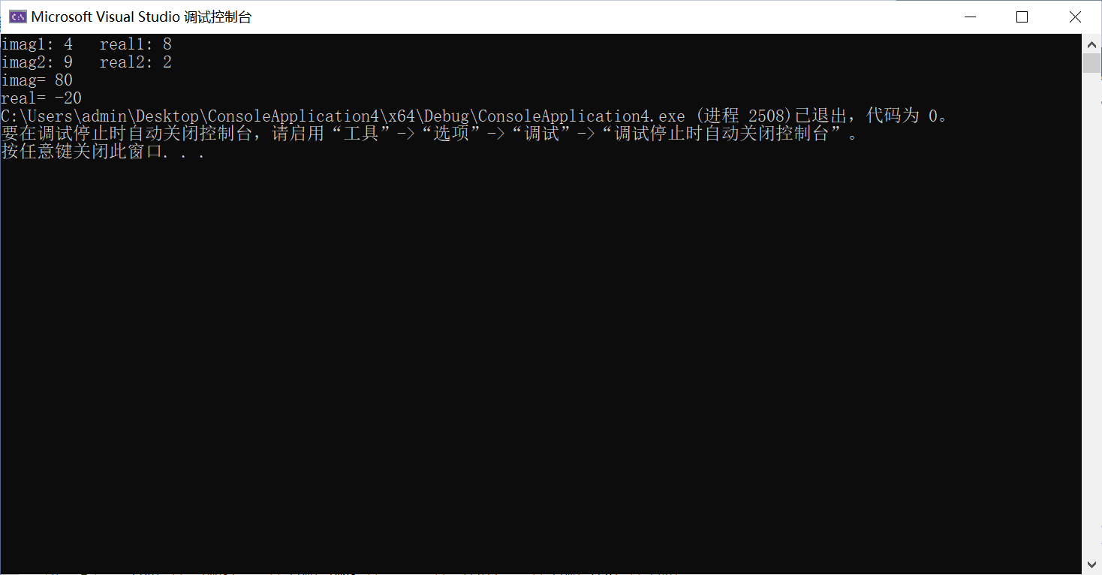

心得感悟：

本次上机是最后一次上机，感觉上机技巧提高了好多.

